

CANDY CRUSH GAME

PF-PROJECT

Talha Rauf

Uzair Azam

***CANDY CRUSH GAME:***

***EASY MODE FUNCTION:***

/*This is the void function which return nothing but take character array,size of array,Time ,move, and score as arguments

This function is used to print the easy bard in game with different colors using textAttribute command*/

void Easy(char arr[][12], int size, int TIME, int MOVE, int Score)

{

cout << endl;

SetConsoleTextAttribute(h, 6);

cout << setw(94) << "<======= EASY MODE =======>" << endl;

SetConsoleTextAttribute(h, 14);

for (int i = 1; i < 168; i++)

{

cout << "_";

}

cout << endl << endl;

SetConsoleTextAttribute(h, 13);

cout << setw(85) << "TIME : " << TIME << " s" << endl << endl;

SetConsoleTextAttribute(h, 3);

cout << setw(85) << "MOVES : " << MOVE << endl << endl;

SetConsoleTextAttribute(h, 10);

cout << setw(85) << "SCORE : " << Score << endl << endl;

SetConsoleTextAttribute(h, 14);

for (int i = 1; i < 168; i++)

{

cout << "-";

}

cout << endl;

SetConsoleTextAttribute(h, 15);

cout << "\t\t\t\t\t\t 1 2 3 4 5 6 7 8 \n";

cout << "\t\t\t\t\t\t _______________________________________________________________\n";

for (int i = 0; i < 8; i++)

{

cout << "\t\t\t\t\t\t| | | | | | | | |";

cout << "\n";

cout << "\t\t\t\t\t " << i + 1 << " | ";

for (int j = 0; j < 8; j++)

{

if (arr[i][j] == '@')

SetConsoleTextAttribute(h, 6);

if (arr[i][j] == '#')

SetConsoleTextAttribute(h, 5);

if (arr[i][j] == '&')

SetConsoleTextAttribute(h, 12);

if (arr[i][j] == '$')

SetConsoleTextAttribute(h, 10);

if (arr[i][j] == '%')

SetConsoleTextAttribute(h, 9);

if (arr[i][j] == 'H')

SetConsoleTextAttribute(h, 4);

if (arr[i][j] == 'B')

SetConsoleTextAttribute(h, 15);

cout << arr[i][j];

SetConsoleTextAttribute(h, 15);

cout << " | ";

}

cout << endl;

cout << "\t\t\t\t\t\t|_______|_______|_______|_______|_______|_______|_______|_______|\n";

}

SetConsoleTextAttribute(h, 14);

for (int i = 1; i < 168; i++)

{

cout << "_";

}

SetConsoleTextAttribute(h, 15);

cout << endl;

}

***OUTPUT:***

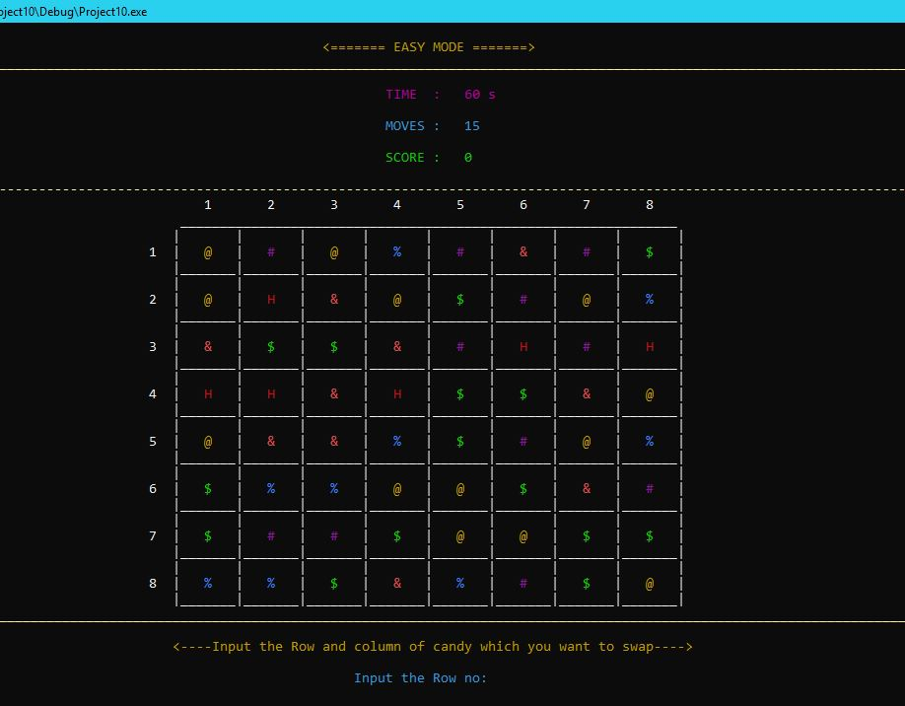

***HARD MODE FUNCTION:***

/*This is the void function which return nothing but take character array,size of array,Time ,move, and score as arguments

This function is used to print the Hard bard in game with different colors using textAttribute command*/

void Hard(char arr2[][12], int size, int TIME, int MOVE, int Score)

{

cout << endl;

SetConsoleTextAttribute(h, 6);

cout << setw(94) << "<======= HARD MODE =======>" << endl;

SetConsoleTextAttribute(h, 14);

for (int i = 1; i < 168; i++)

{

cout << "_";

}

//SetConsoleTextAttribute(h, 15);

cout << endl << endl;

SetConsoleTextAttribute(h, 13);

cout << setw(85) << "TIME : " << TIME << " s" << endl << endl;

SetConsoleTextAttribute(h, 3);

cout << setw(85) << "MOVES : " << MOVE << endl << endl;

SetConsoleTextAttribute(h, 10);

cout << setw(85) << "SCORE : " << Score << endl << endl;

SetConsoleTextAttribute(h, 14);

for (int i = 1; i < 168; i++)

{

cout << "-";

}

cout << endl;

SetConsoleTextAttribute(h, 15);

cout << "\t\t\t\t 1 2 3 4 5 6 7 8 9 10 11 12 \n";

cout << "\t\t\t\t _______________________________________________________________________________________________\n";

for (int i = 0; i < 12; i++)

{

cout << "\t\t\t\t| | | | | | | | | | | | |";

cout << "\n";

if (i < 9)

cout << "\t\t\t " << i + 1 << " | ";

else

cout << "\t\t\t " << i + 1 << " | ";

for (int j = 0; j < 12; j++)

{

if (arr2[i][j] == '@')

SetConsoleTextAttribute(h, 6);

if (arr2[i][j] == '#')

SetConsoleTextAttribute(h, 5);

if (arr2[i][j] == '&')

SetConsoleTextAttribute(h, 12);

if (arr2[i][j] == '$')

SetConsoleTextAttribute(h, 10);

if (arr2[i][j] == '%')

SetConsoleTextAttribute(h, 9);

if (arr2[i][j] == 'H')

SetConsoleTextAttribute(h, 4);

if (arr2[i][j] == '!')

SetConsoleTextAttribute(h, 14);

if (arr2[i][j] == '0')

SetConsoleTextAttribute(h, 2);

if (arr2[i][j] == '?')

SetConsoleTextAttribute(h, 11);

if (arr2[i][j] == 'B')

SetConsoleTextAttribute(h, 15);

cout << arr2[i][j];

SetConsoleTextAttribute(h, 15);

cout << " | ";

}

cout << endl;

cout << "\t\t\t\t|_______|_______|_______|_______|_______|_______|_______|_______|_______|_______|_______|_______|\n";

}

SetConsoleTextAttribute(h, 14);

for (int i = 1; i < 168; i++)

{

cout << "_";

}

SetConsoleTextAttribute(h, 15);

cout << endl;

}

/*This function is the integer fuction which return 0 and have no arrguments.This function is used to take input

the movement of candy up, down, right and left*/

int input()

{

SetConsoleTextAttribute(h, 15);

cout << "\n\n";

cout << setw(94) << "* Press 1 to move candy UP:";

cout << "\n\n";

cout << setw(96) << "* Press 2 to move candy DOWN:";

cout << "\n\n";

cout << setw(96) << "* Press 3 to move candy LEFT:";

cout << "\n\n";

cout << setw(98) << "* Press 4 to move candy RIGHT: ";

cout << "\n\n";

cout << setw(93) << "Input The Number Here:";

while (!(cin >> number))//Run loop until user enter correct input

{

SetConsoleTextAttribute(h, 4);

cout << setw(93) << "Input the number Again:";

cin.clear();//If output is not correct then clear the input

cin.ignore();

}

return 0;

SetConsoleTextAttribute(h, 15);

}

***OUTPUT:***

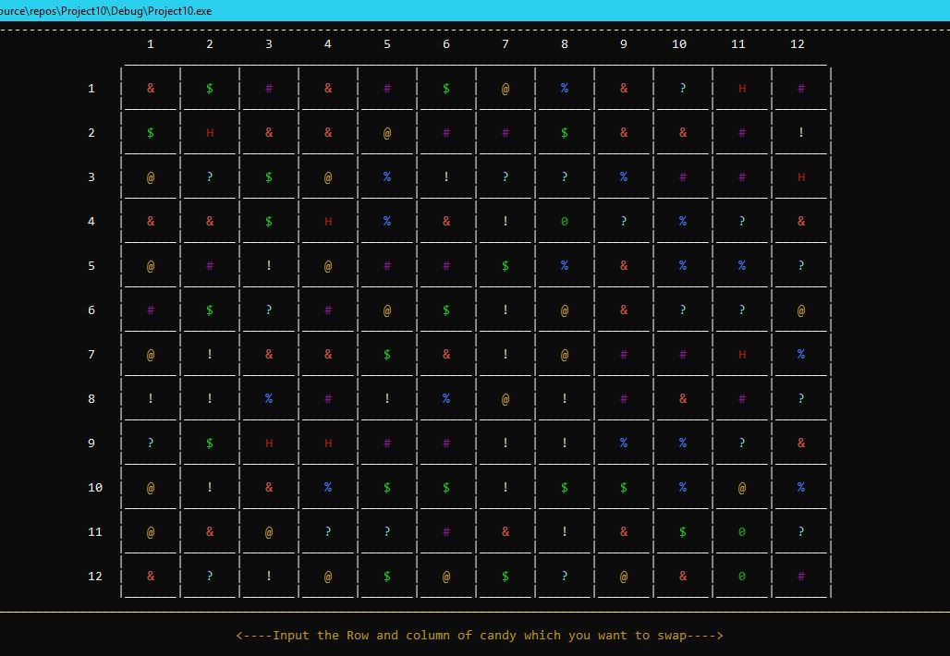

***MENU:***

sndPlaySound(TEXT("Candy Crush Intro2.wav"), SND_FILENAME | SND_ASYNC | SND_LOOP);// plays a waveform sound specified either by a file name

num = 0;

system("cls");// to clear the screen

cout << "\n";

SetConsoleTextAttribute(h, 9);// To change console application text color

cout << setw(96) << "<---(*CANDY CRUSH GAME*)--->";

cout << endl;

SetConsoleTextAttribute(h, 14);// To change console application text color

for (int i = 1; i < 168; i++)// loop to print a line

{

cout << "_";

}

cout << endl << endl;

SetConsoleTextAttribute(h, 6);// To change console application text color

cout << setw(91) << "<---MAIN MENU--->" << endl;

cout << endl;

SetConsoleTextAttribute(h, 13); //To change console application text color

cout << setw(87) << "1 --- PLAY GAME" << endl << endl;

if (num == 1)

{

SetConsoleTextAttribute(h, 11);// To change console application text color

cout << setw(92) << "1 -- EASY MODE" << endl;

cout << setw(92) << "2 -- HARD MODE" << endl << endl;

}

SetConsoleTextAttribute(h, 14);// To change console application text color

cout << setw(85) << "2 --- CREDITS" << endl << endl;

SetConsoleTextAttribute(h, 12);// To change console application text color

cout << setw(96) << "3 --- INSTRUCTIONS/RULES" << endl << endl;

SetConsoleTextAttribute(h, 10);// To change console application text color

cout << setw(83) << "4 --- SCORE" << endl << endl;

SetConsoleTextAttribute(h, 4);// To change console application text color

cout << setw(82) << "5 --- EXIT" << endl << endl;

SetConsoleTextAttribute(h, 14);// To change console application text color

for (int i = 1; i < 168; i++)// loop to print a line

{

cout << "-";

}

cout << endl << endl;

SetConsoleTextAttribute(h, 3);// To change console application text color

cout << setw(90) << "Input the number here:";

while (!(cin >> num))// Checking that input is valid or not

{

SetConsoleTextAttribute(h, 4);// To change console application text color

cout << setw(90) << "Input the number Again:";

cin.clear();// clears the error flag on cin

cin.ignore();// to ignore or clear one or more characters

}

SetConsoleTextAttribute(h, 15);// To change console application text color

cout << endl;

***OUTPUT:***

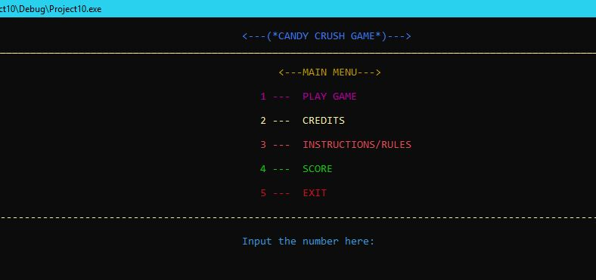

***STARTING LOGO:***

SetConsoleTextAttribute(h, 6);

cout << "\n\n\n\n\n\n\n\n\n\n\n";

cout << setw(95) << " *** ** ** *** ** ** ** ** ** \n";

cout << setw(95) << " ** ** ** ** ** ** ** ** ** ** \n";

cout << setw(95) << " ** ** ** ** ** ** ** ** ** ** \n";

cout << setw(95) << " ** ********** ** ** ** ** ** ** \n";

cout << setw(95) << " ** ** ** ** ** ** ** ** ** \n";

cout << setw(95) << " *** ** ** ** ** *** ** ** ** \n";

cout << "\n\n\n\n\n";

SetConsoleTextAttribute(h, 6);

cout << setw(115) << " *** ** *** ** ** ** *** ** ** \n";

cout << setw(115) << " *** ** ** ** ** *** *** ** ** \n";

cout << setw(115) << " *** ** ** ** ** *** ** ** \n";

cout << setw(115) << " *** ** **** ** ** *** ********** \n";

cout << setw(115) << " *** ** ** ** ** *** ** ** \n";

cout << setw(115) << " *** ** ** ** ** *** *** ** ** \n";

cout << setw(115) << " *** ** ** ** ** ** *** ** ** \n";

Sleep(50000);

***OUTPUT:***

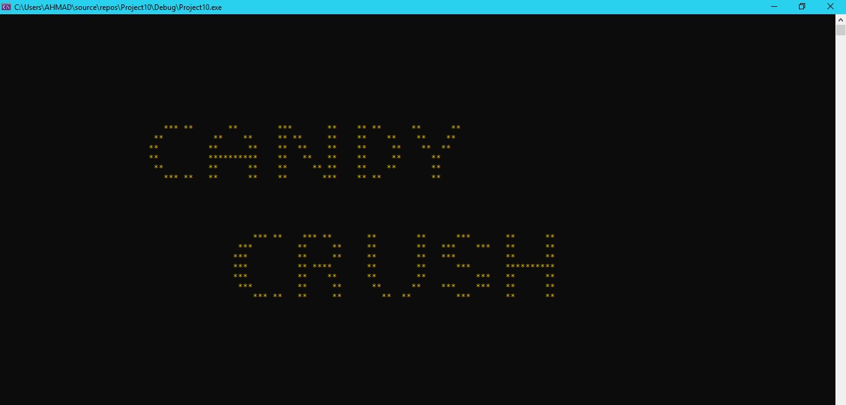

***MOD SELECTER AND INPUT NAME:***

system("cls");// to clear the screen

cout << endl;

SetConsoleTextAttribute(h, 6);// To change console application text color

for (int i = 1; i < 168; i++)// loop to print a line

{

cout << "*";

}

cout << endl << endl;

cin.ignore();// to ignore or clear one or more characters

SetConsoleTextAttribute(h, 14);// To change console application text color

cout << setw(84) << "ENTER YOUR NAME :";

getline(cin, name);

system("cls"); // to clear the screen

cout << endl;

SetConsoleTextAttribute(h, 9);// To change console application text color

cout << setw(96) << "<---(*CANDY CRUSH GAME*)--->" << endl;

cout << endl;

SetConsoleTextAttribute(h, 14);// To change console application text color

for (int i = 1; i < 168; i++)// loop to print a line

{

cout << "_";

}

cout << endl << endl;

SetConsoleTextAttribute(h, 6);// To change console application text color

cout << setw(91) << "<---MAIN MENU--->" << endl;

cout << endl;

SetConsoleTextAttribute(h, 13);// To change console application text color

cout << setw(87) << "1 --- PLAY GAME" << endl << endl;

if (num == 1)

{

SetConsoleTextAttribute(h, 11);

cout << setw(92) << "1 -- EASY MODE" << endl;

cout << setw(92) << "2 -- HARD MODE" << endl << endl;

}

SetConsoleTextAttribute(h, 14);

cout << setw(85) << "2 --- CREDITS" << endl << endl;

SetConsoleTextAttribute(h, 12);// To change console application text color

cout << setw(96) << "3 --- INSTRUCTIONS/RULES" << endl << endl;

SetConsoleTextAttribute(h, 10);// To change console application text color

cout << setw(83) << "4 --- SCORE" << endl << endl;

SetConsoleTextAttribute(h, 4);// To change console application text color

cout << setw(82) << "5 --- EXIT" << endl << endl;

SetConsoleTextAttribute(h, 14);// To change console application text color

for (int i = 1; i < 168; i++)// loop to print a line

{

cout << "-";

}

cout << endl << endl;

SetConsoleTextAttribute(h, 3);// To change console application text color

cout << setw(90) << "Input the Mod number here:";

while (!(cin >> mod))// Checking that input is valid or not

{

SetConsoleTextAttribute(h, 4);// to ignore or clear one or more characters

cout << setw(90) << "Input the Mod number again:";

cin.clear();// to clear the screen

cin.ignore();// to ignore or clear one or more characters

}

SetConsoleTextAttribute(h, 15);// to ignore or clear one or more characters

cout << endl;

***OUTPUT:***

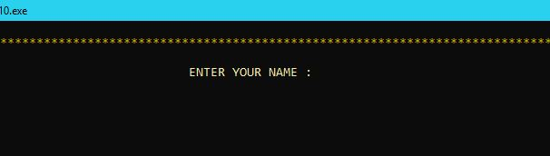

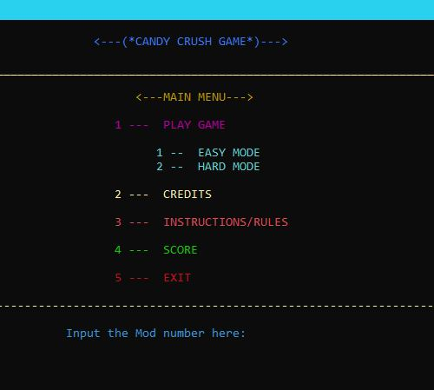

***CREDITS:***

system("cls");// to clear the screen

sndPlaySound(TEXT("credit2.wav"), SND_FILENAME | SND_ASYNC | SND_LOOP);

cout << endl;

SetConsoleTextAttribute(h, 6);// To change console application text color

cout << "\n";

for (int i = 1; i < 168; i++)// usimg for loop

{

cout << "&";

}

cout << endl << endl;

cout << setw(100) << "<<<==----- CREDITS -----==>>>" << endl << endl;

for (int i = 1; i < 168; i++)

{

cout << "&";

}

SetConsoleTextAttribute(h, 7);// To change console application text color

cout << endl << endl;

Sleep(3000);// to suspend its execution temporarily for a period of time in seconds specified by the function

sndPlaySound(TEXT("credit.wav"), SND_FILENAME | SND_ASYNC);// plays a waveform sound specified either by a file name

Sleep(1200);

cout << setw(79); cout << "M", Sleep(150), cout << "U", Sleep(150), cout << "H", Sleep(150), cout << "A", Sleep(150);

cout << "M", Sleep(150), cout << "M", Sleep(150), cout << "A", Sleep(150), cout << "D", Sleep(150), cout << " ", Sleep(150);

cout << "A", Sleep(150), cout << "H", Sleep(150), cout << "M", Sleep(150), cout << "A", Sleep(150), cout << "D";

cout << endl << endl;

sndPlaySound(TEXT("credit.wav"), SND_FILENAME | SND_ASYNC);// plays a waveform sound specified either by a file name

Sleep(1200);

cout << setw(78); cout << "M", Sleep(130), cout << "U", Sleep(130), cout << "H", Sleep(130), cout << "A", Sleep(130);

cout << "M", Sleep(130), cout << "M", Sleep(130), cout << "A", Sleep(130), cout << "D", Sleep(130), cout << " ", Sleep(130);

cout << "H", Sleep(130), cout << "U", Sleep(130), cout << "Z", Sleep(130), cout << "A", Sleep(130), cout << "I", Sleep(130), cout << "F", Sleep(130), cout << "A";

Sleep(1000);

sndPlaySound(TEXT("credit2.wav"), SND_FILENAME | SND_ASYNC | SND_LOOP);// plays a waveform sound specified either by a file name

cout << endl << endl;

system("pause");

break;

***OUTPUT:***

***INSTRUCTIONS:***

sndPlaySound(TEXT("rules.wav"), SND_FILENAME | SND_ASYNC | SND_LOOP);// plays a waveform sound specified either by a file name

system("cls");

SetConsoleTextAttribute(h, 6);// To change console application text color

cout << "\n";

for (int i = 1; i < 168; i++)// using for loop

{

cout << "&";

}

cout << endl << endl;

cout << setw(107) << "<<<==----- RULES AND INSTRUCTIONS -----==>>>" << endl << endl;

for (int i = 1; i < 168; i++)// using for loop

{

cout << "&";

}

SetConsoleTextAttribute(h, 11);// To change console application text color

cout << "\n\n\n";

cout << "==> 1. There are two types of boards in this Game, one is easy and second is hard\n\n";

cout << "==> 2. The Easy board contain 8x8 candies means 64 candies and a timer of 60 seconds and 15 moves\n\n";

cout << "==> 3. The Hard board contain 12x12 candies means 144 candies and a timer of 40 seconds and 15 moves\n\n";

cout << "==> 4. The Easy board contain 6 Hardles candies Which are not swappable and the player can not swap\n other candies with Hurdles Candies\n\n";

cout << "==> 5. The Hard board contain 11 Hardles candies Which are not swappable and the player can not swap\n other candies with Hurdles Candies\n\n";

cout << "==> 6. The Player have to swap the candies with other candies only and only if three or more than\n three candies become in consective row or column\n\n";

cout << "==> 7. In this game Player have to enter the row and column number of candy which he want to swap\n\n";

cout << "==> 8. When the player matches three candies then he / she get 10 points and moves decreased by 1\n\n";

cout << "==> 9. When the player matches more than three candies then he / she get 20 points and a candy (B)\n called BOMB come to swapplable candy place and moves decreased by 1\n\n";

cout << "==> 10. When the player swap bomb with any candy except Hardles then he / she get 30 points and a \n whole row and column of swappable candy will removed and new candies come on that place and\n moves decreased by 1\n\n";

cout << "==> 11. When Time or Moves end then game End and if he / she have more score then top three then \n he / she get score in top three\n\n";

SetConsoleTextAttribute(h, 14);// To change console application text color

cout << "\n\n" << setw(100) << "Hope you Enjoy the game :):)\n\n";

SetConsoleTextAttribute(h, 6);// To change console application text color

for (int i = 1; i < 168; i++)// using for loop

{

cout << "=";

}

cout << endl;

SetConsoleTextAttribute(h, 7);// To change console application text color

system("pause");

***OUTPUT:***

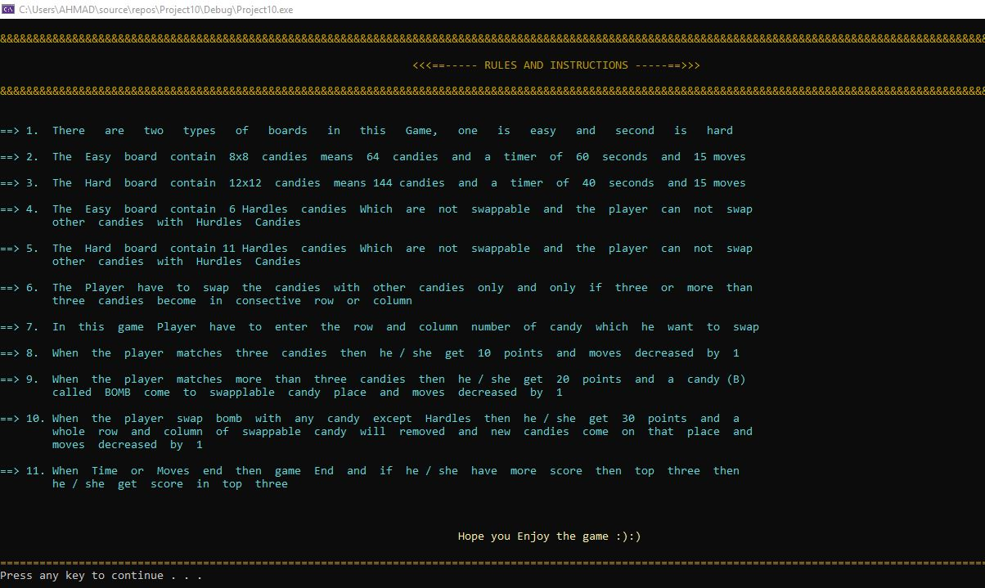

***SCORES:***

system("cls");

SetConsoleTextAttribute(h, 6);// To change console application text color

cout << "\n";

for (int i = 1; i < 168; i++)

{

cout << "&";

}

cout << endl << endl;

cout << setw(103) << "<<<=----TOP THREE HIGH SCORES----=>>>" << endl << endl;

for (int i = 1; i < 168; i++)// using for loop

{

cout << "&";

}

cout << "\n\n\n\n";

DATA3.open("DATA.txt");

if (DATA3.is_open())

{

getline(DATA3, name1);//used to read a string or a line from an file

DATA3 >> score2[0];

DATA3.ignore();//clear one or more characters from the input

getline(DATA3, name2);//used to read a string or a line from an file

DATA3 >> score2[1];

DATA3.ignore();//clear one or more characters from the input

getline(DATA3, name3);//used to read a string or a line from an file

DATA3 >> score2[2];

DATA3.ignore();//clear one or more characters from the input

SetConsoleTextAttribute(h, 4);// To change console application text color

cout << setw(85) << "NAME OF PLAYERS" << " : " << "SCORES" << endl << endl;

SetConsoleTextAttribute(h, 9);

cout << setw(85) << name1 << " : " << score2[0] << endl;

cout << setw(85) << name2 << " : " << score2[1] << endl;

cout << setw(85) << name3 << " : " << score2[2] << endl;

SetConsoleTextAttribute(h, 6);// To change console application text color

cout << "\n\n\n\n";

for (int i = 1; i < 168; i++)// using for loop

{

cout << "=";

}

cout << endl;

system("pause");

SetConsoleTextAttribute(h, 15);// To change console application text color

}

else

{

SetConsoleTextAttribute(h, 4);// To change console application text color

cout << setw(103) << "<<<<<<<<< NO HIGH SCORE YET >>>>>>>>>" << endl << endl;

cout << "\n\n\n\n";

SetConsoleTextAttribute(h, 6);// To change console application text color

for (int i = 1; i < 168; i++)// using for loop

{

cout << "=";

}

cout << endl;

system("pause");

SetConsoleTextAttribute(h, 15);// To change console application text color

}

***SCORECHECKER FUNCTION:***

/*This function is the integer which return check or 0 integer and take arguments as integer array,size,Score,string name and string values as reference

This function check that if score is greter or not than other stored three scores in array and change them and also change name according

to score*/

int scorechecker(int score[], int size, int Score, string name, string& name1, string& name2, string& name3)

{

int temp, temp2;

int i, check = 0, sure = 0;

for (i = 0; i < 3; i++)

{

if (Score > score[i])

{

temp = score[i];

score[i] = Score;

temp2 = score[i + 1];

score[i + 1] = temp;

score[i + 2] = temp2;

check = check + 1;

i = 3;

sure = 1;

}

else

check = check + 1;

}

if (check == 1 && sure == 1)

{

name3 = name2;

name2 = name1;

name1 = name;

}

if (check == 2 && sure == 1)

{

name3 = name2;

name2 = name;

name1 = name1;

}

if (check == 3 && sure == 1)

{

name1 = name1;

name2 = name2;

name3 = name;

}

if (sure == 0)

{

name1 = name1;

name2 = name2;

name3 = name3;

}

if (sure == 0)

return 0;

else

return check;

}

***OUTPUT:***

***BOMB FUNCTION:***

/*This is the integer function named as bomb which take bomb,move and score as reference arrguments androw and column as integer argumentsand return 0

This fuction checks that wheter the user select bomb and swap it on right place means check that is bomb swap with hardles or not

if user select 1 candy it can not swap up and left and so on if bomb is valid then it changes the row in 1 and column in 0*/

int Bomb(int row, int column,char arr[][12],int size,int& bomb,int& move,int& Score)

{

SetConsoleTextAttribute(h, 4);

int count=0;

row = row - 1;

column = column - 1;

if (number == 1)

{

if(arr[row - 1][column] != 'H'&& row!=0)

{

count = 1;

sndPlaySound(TEXT("colour_bomb1.wav"), SND_FILENAME | SND_ASYNC);

for (int i = 0; i < size; i++)

{

arr[i][column] = '1';

}

for (int j = 0; j < size; j++)

{

arr[row-1][j] = '0';

}

Sleep(600);

Score = Score + 30;

bomb = 1;

}

else

{

cout << "\n";

cout << setw(108) << "!!!!!!!!!! You can not swap this candy to UP !!!!!!!!!! " << "\n";

Sleep(800);

move = move + 1;

}

}

else if (number == 2)

{

if(arr[row+1][column] != 'H' && row != size-1)

{

count = 1;

sndPlaySound(TEXT("colour_bomb1.wav"), SND_FILENAME | SND_ASYNC);

for (int i = 0; i < size; i++)

{

arr[i][column] = '1';

}

for (int j = 0; j < size; j++)

{

arr[row + 1][j] = '0';

}

Sleep(600);

Score = Score + 30;

bomb = 1;

}

else

{

cout << "\n";

cout << setw(109) << "!!!!!!!!!! You can not swap this candy to DOWN !!!!!!!!!! " << "\n";

Sleep(800);

move = move + 1;

}

}

else if (number == 3)

{

if(arr[row][column - 1] != 'H' && column != 0)

{

count = 1;

sndPlaySound(TEXT("colour_bomb1.wav"), SND_FILENAME | SND_ASYNC);

for (int i = 0; i < size; i++)

{

arr[row][i] = '0';

}

for (int j = 0; j < size; j++)

{

arr[j][column-1] = '1';

}

Sleep(600);

Score = Score + 30;

bomb = 1;

}

else

{

cout << "\n";

cout << setw(109) << "!!!!!!!!!! You can not swap this candy to LEFT !!!!!!!!!! " << "\n";

Sleep(800);

move = move + 1;

}

}

else

if (arr[row][column + 1] != 'H' && column != size-1)

{

count = 1;

sndPlaySound(TEXT("colour_bomb1.wav"), SND_FILENAME | SND_ASYNC);

for (int i = 0; i < size; i++)

{

arr[row][i] = '0';

}

for (int j = 0; j < size; j++)

{

arr[j][column + 1] = '1';

}

Sleep(600);

Score = Score + 30;

bomb = 1;

}

else

{

cout << "\n";

cout << setw(109) << "!!!!!!!!!! You can not swap this candy to RIGHT !!!!!!!!!!" << "\n";

Sleep(800);

move = move + 1;

}

SetConsoleTextAttribute(h, 15);

return 0;

}

***OUTPUT:***

